**Form Menu (Pertemuan ke 12)**

* Jalankan XAMPP terlebih dahulu

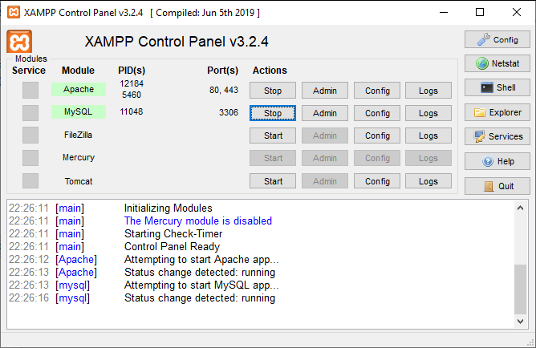

Output program :

**Contoh program sebagai berikut :**

Ganti dengan **NIM dan Nama**

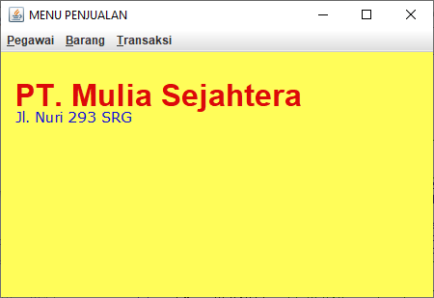

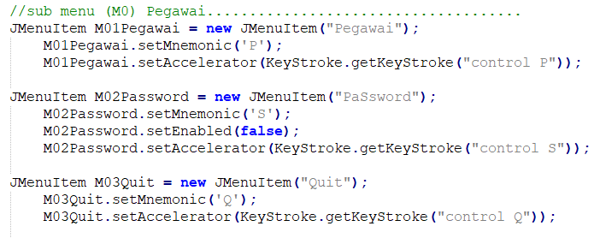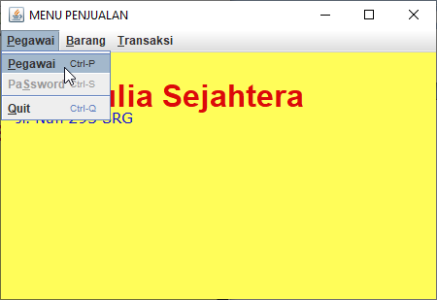

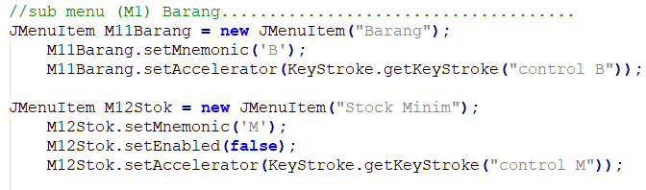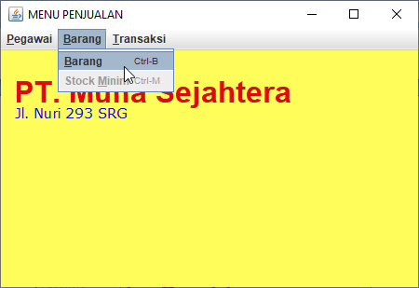

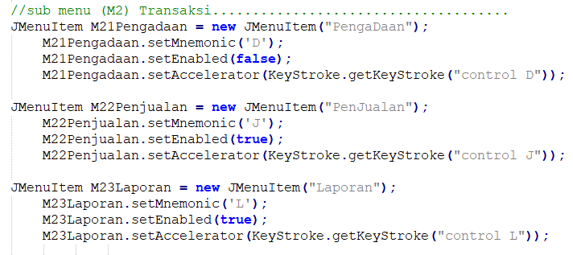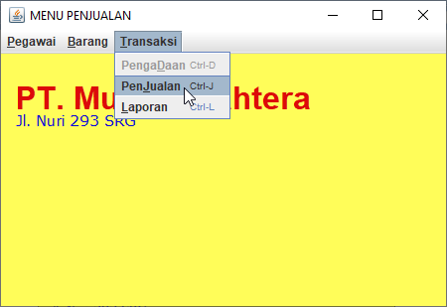

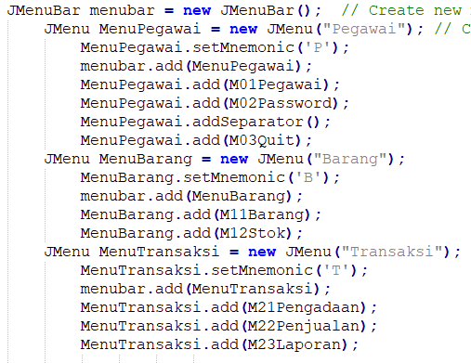



Kode program :

import java.awt.*;

import java.awt.event.*;

import javax.swing.*;

import javax.swing.event.*;

// Program Menu..........................................................

class FMenu06284 extends JFrame

{

// property/fields...................................................

private JTextArea m_editArea = new JTextArea(20, 50);

private JPanel JPMenu = new JPanel();

private JPopupMenu m_popup = new JPopupMenu();

private JLabel lNama = new JLabel ("Dewi Putri AyuNingsih"),

lNim = new JLabel ("A12.2019.06284");

//Nama Ganti dengan Nama dan NIM anda.......... !

// constructor.......................................................

public FMenu06284() // 06284 ganti dengan 5 digit nim terakhir......

{

setPreferredSize(new Dimension(800,600));

setTitle("MENU PENJUALAN");

JDesktopPane JDPMenu = new JDesktopPane();

setDefaultCloseOperation(JFrame.EXIT_ON_CLOSE);

lNama.setBounds (15, 20, 400, 50);

lAlamat.setBounds (15, 55, 200, 25);

lNama.setFont(new Font("Arial", Font.BOLD, 32));

lNama.setForeground(new Color(220, 10, 10));

lAlamat.setFont(new Font("Verdana", Font.PLAIN, 15));

lAlamat.setForeground(new Color(10, 10, 220));

//sub menu (M0) Pegawai.....................................

JMenuItem M01Pegawai = new JMenuItem("Pegawai");

M01Pegawai.setMnemonic('P');

M01Pegawai.setAccelerator(KeyStroke.getKeyStroke("control P"));

JMenuItem M02Password = new JMenuItem("PaSsword");

M02Password.setMnemonic('S');

M02Password.setEnabled(false);

M02Password.setAccelerator(KeyStroke.getKeyStroke("control S"));

JMenuItem M03Quit = new JMenuItem("Quit");

M03Quit.setMnemonic('Q');

M03Quit.setAccelerator(KeyStroke.getKeyStroke("control Q"));

//sub menu (M1) Barang.....................................

JMenuItem M11Barang = new JMenuItem("Barang");

M11Barang.setMnemonic('B');

M11Barang.setAccelerator(KeyStroke.getKeyStroke("control B"));

JMenuItem M12Stok = new JMenuItem("Stock Minim");

M12Stok.setMnemonic('M');

M12Stok.setEnabled(false);

M12Stok.setAccelerator(KeyStroke.getKeyStroke("control M"));

//sub menu (M2) Transaksi.....................................

JMenuItem M21Pengadaan = new JMenuItem("PengaDaan");

M21Pengadaan.setMnemonic('D');

M21Pengadaan.setEnabled(false);

M21Pengadaan.setAccelerator(KeyStroke.getKeyStroke("control D"));

JMenuItem M22Penjualan = new JMenuItem("PenJualan");

M22Penjualan.setMnemonic('J');

M22Penjualan.setEnabled(true);

M22Penjualan.setAccelerator(KeyStroke.getKeyStroke("control J"));

JMenuItem M23Laporan = new JMenuItem("Laporan");

M23Laporan.setMnemonic('L');

M23Laporan.setEnabled(true);

M23Laporan.setAccelerator(KeyStroke.getKeyStroke("control L"));

// (2) Build menubar, menus, and add menuitems....................

JMenuBar menubar = new JMenuBar(); // Create new menu bar.........

JMenu MenuPegawai = new JMenu("Pegawai"); // Create new menu...

MenuPegawai.setMnemonic('P');

menubar.add(MenuPegawai);

MenuPegawai.add(M01Pegawai);

MenuPegawai.add(M02Password);

MenuPegawai.addSeparator();

MenuPegawai.add(M03Quit);

JMenu MenuBarang = new JMenu("Barang");

MenuBarang.setMnemonic('B');

menubar.add(MenuBarang);

MenuBarang.add(M11Barang);

MenuBarang.add(M12Stok);

JMenu MenuTransaksi = new JMenu("Transaksi");

MenuTransaksi.setMnemonic('T');

menubar.add(MenuTransaksi);

MenuTransaksi.add(M21Pengadaan);

MenuTransaksi.add(M22Penjualan);

MenuTransaksi.add(M23Laporan);

//Siap untuk menjalankan pilihan.....................

M01Pegawai.addActionListener(new BukaPegawai());

M03Quit.addActionListener(new QuitAction());

M11Barang.addActionListener(new OpenAction());

M22Penjualan.addActionListener(new BukaJual());

M23Laporan.addActionListener(new Laporan());

// Add the (unused) text area to the content pane............

JPanel content = new JPanel();

content.setLayout(new BorderLayout());

content.add(m_editArea, BorderLayout.CENTER);

//... Add menu items to popup menu, add popup menu to text area.

m_popup.add(new JMenuItem("Testing"));

m_editArea.setComponentPopupMenu(m_popup);

//... Set the JFrame's content pane and menu bar.

setContentPane(content);

setJMenuBar(menubar);

JDPMenu.add (lNama);

JDPMenu.add (lAlamat);

getContentPane().add (JDPMenu).setBackground(Color.getHSBColor(180,100,200));

pack();

setLocationRelativeTo(null);

}

class OpenAction implements ActionListener {

public void actionPerformed(ActionEvent e) {

JOptionPane.showMessageDialog(FMenu05049.this, "Can't Open.");

}

}

class BukaPegawai implements ActionListener {

public void actionPerformed(ActionEvent e) {

// FPegawai06284 xPegawai = new FPegawai06284();

// xPegawai.setVisible(true);

// dua perintah diatas "//"nya dihapus !

//..........................................

//panggil Form pegawai untuk menjalankan program pegawai !

//Perintah System.exit(0); pada FPegawai ganti dengan perintah

// this.dispose();

// System.exit(0); menjadi this.dispose();

}

}

class BukaBarang implements ActionListener {

public void actionPerformed(ActionEvent e) {

//FBarang06284 xBarang = new FBarang06284();

//xBarang.setVisible(true);

}

}

class BukaJual implements ActionListener {

public void actionPerformed(ActionEvent e) {

//FJual06284 xJual = new FJual06284();

//xJual.setVisible(true);

}

}

class Laporan implements ActionListener {

public void actionPerformed(ActionEvent e) {

//CetakBrg06284 xLaporan = new CetakBrg06284();

//xLaporan.setVisible(true);

}

}

class QuitAction implements ActionListener {

public void actionPerformed(ActionEvent e) {

System.exit(0); // Terminate the program..........

}

}

// main method................................................

public static void main(String[] args) {

JFrame win = new FMenu06284();

win.setVisible(true);

}

}

Selamat mencoba